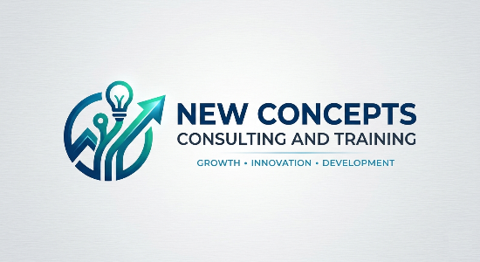
ENTERPRISE CORPORATE PROPOSAL
Technical-to-Management Cohort Accelerator & PMP® Readiness Program
Prepared For: Click or tap here to enter text.
Target Group: Click or tap here to enter text.
Prepared By: Jyotsna Pai, Principal Consultant at Mindset Decoded
Date: May 2026
Document Ref: MD-PROP-2026-001-V1

1. Executive Summary & Objective
In modern, fast-paced technical environments, transitioning highly skilled technical specialists (such as developers, system architects, and tech leads) into effective project leaders is a critical organizational challenge. Technical minds excel at algorithmic logic but frequently struggle with the highly fluid, behavioural, and situational logic demanded by enterprise frameworks like the PMI Examination Content Outline (ECO).
Mindset Decoded provides a proprietary, turnkey delivery engine that bridges this cognitive gap. This program does not teach passive textbook memorization. Instead, it systematically implants an enterprise-grade "Situational Mindset" into your engineering cohorts, rapidly accelerating their PMP® pass rates while immediately improving their cross-functional project delivery.

2. The Core Methodological Frameworks
Every candidate enrolled in this enterprise accelerator gains access to the proprietary frameworks established in the 600+ page textbook, PMP Mindset Decoded, authored by Jyotsna Pai:
- The 4-Step Evaluation Flow: A strict, repeatable engineering-style workflow (Assess Consult Plan Act) that teaches technical professionals how to systematically evaluate situational project impacts before taking reactive operational risks.
- 13 Predictive Mindset Rules: Grounded heavily in the core behavioural categories of modern delivery (Servant Leadership, Value Delivery, and Change Control), these rules eliminate exam anxiety by providing hard guardrails for analysing complex, ambiguous scenario-based questions.
- The Systematic 4-Step Evaluation Model: Custom-tailored mechanics that teach candidates how to prioritize competing constraints (Scope, Budget, Schedule, Quality) dynamically under intense test-day pacing.
3. Program Structure & Deliverables
This cohort accelerator is executed over a structured 4-to-6-week hybrid runway, optimized to ensure zero disruption to your active development pipelines:
Phase | Milestone / Deliverable | Focus & Outcome
Phase 1 | Technical Alignment & Blueprint Integration | 1-on-1 Application Auditing and alignment of current engineering sprint habits with PMBOK® 7/8 task logic.
Phase 2 | Core Masterclasses (Virtual or Hybrid Delivery) | Intensive deep-dives into the 13 Predictive Rules and the 4-Step Evaluation Flow using real-world situational case studies.
Phase 3 | Forensic Mock Exam Analysis | Deep-dive tracking of candidate test metrics to uncover cognitive blind spots and eliminate reactive decision patterns.
Phase 4 | Final Readiness Certification | Final stamina, pacing, and test-day fatigue optimization drills to guarantee an "Above Target" delivery mindset.

Included Materials:
- Full corporate licensing and physical copies of the 600+ page textbook PMP Mindset Decoded for every enrolled participant.
- Full access to our proprietary bank of 500 expert-level situational practice questions.
4. Commercial Options & Investment Tiering
To provide maximum operational flexibility, select the investment tier that matches your current department parameters:
Option A: The Team Accelerator Cohort (Up to 10 Participants)
- Best For: Specialized software engineering squads or newly promoted technical team leads.
- Includes: 10x Copies of PMP Mindset Decoded, full virtual workshop delivery, application vetting, and group forensic exam reviews.
- Investment: $13,500 AUD (Flat Package Rate)
Option B: Elite Executive 1-on-1 VIP Mentorship (Per Individual)
- Best For: High-potential Senior Managers, Engineering Directors, or Enterprise Architects fast-tracking to operational leadership.
- Includes: Direct, private continuous access to Jyotsna Pai, customized mock exam forensics, personalized application structural polish, and WhatsApp emergency support.
- Investment: $2,450 AUD (Per Participant)
Option C: Enterprise Associate Day-Rate Delivery (ATO/ATP Model)
- Best For: Authorized Training Organizations requiring white-glove, expert contractor delivery for their Tier-1 corporate clients.
- Includes: Complete plug-and-play facilitation of established schedules utilizing the Mindset Decoded authority asset.
- Investment: $1,100 AUD / Day (Minimum 4-Day Engagement)
5. Terms, Conditions, & Next Steps
- Validity: This proposal and its commercial models remain valid for 60 days from the issue date.
- Payment Terms: 50% mobilization fee required upon contract signing; 50% upon completion of the final delivery milestone.
- Scheduling: Cohort commencement dates are secured on a first-come, first-served basis upon receipt of deposit.

How to Proceed:
To accept this proposal or request a technical scoping calibration call, please contact us.
Jyotsna Pai
Principal Consultant | Mindset Decoded
Author of PMP Mindset Decoded | PMP® | CSM® | Safe® 6.0
E: Jyotsna.pai@mindsetdecoded.com.au
W: mindsetdecoded.com.au

